Proxy Statement Pursuant to Section 14(a) of the
Securities Exchange Act of 1934

Filed by the Registrant ☒
Filed by a Party other than the Registrant ☐
Check the appropriate box:

☐ | Preliminary Proxy Statement

☐ | Confidential, For Use of the Commission Only (as permitted by Rule 14a-6(e)(2))

☐ | Definitive Proxy Statement

☒ | Definitive Additional Materials

☐ | Soliciting Material Pursuant to Rule 14a-11(c) or rule 14a-12
Red Violet, Inc.
(Name of Registrant as Specified In Its Charter)
(Name of Person(s) Filing Proxy Statement, if Other Than the Registrant)
Payment of Filing Fee (Check the appropriate box):

☒ | No fee required.

☐ | Fee paid previously with preliminary materials

☐ | Fee computed on table in exhibit required by Item 25(b) per Exchange Act Rules 14a-6(i)(1) and 0-11

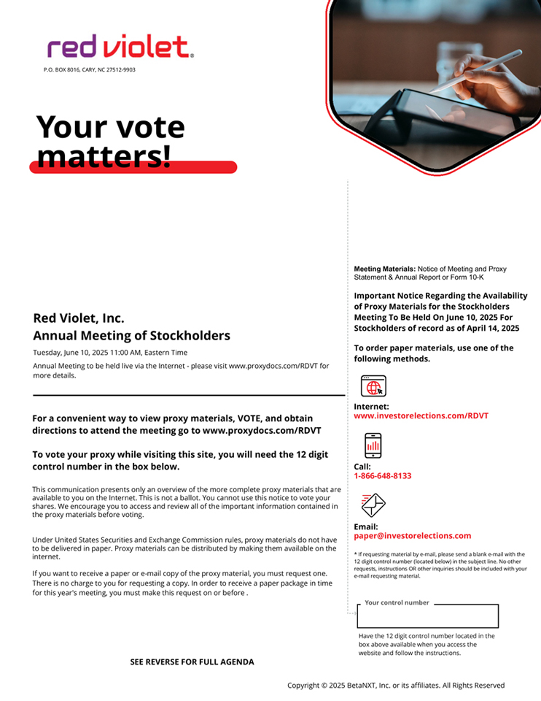
P.O. BOX 8016, CARY, NC 27512-9903 Meeting Materials: Notice of Meeting and Proxy Statement & Annual Report or Form 10-K Important Notice Regarding the Availability of Proxy Materials for the Stockholders Red Violet, Inc. Meeting To Be Held On June 10, 2025 For Stockholders of record as of April 14, 2025 Annual Meeting of Stockholders To order paper materials, use one of the Tuesday, June 10, 2025 11:00 AM, Eastern Time Annual Meeting to be held live via the Internet - please visit www.proxydocs.com/RDVT for following methods. more details. Internet: For a convenient way to view proxy materials, VOTE, and obtain www.investorelections.com/RDVT directions to attend the meeting go to www.proxydocs.com/RDVT To vote your proxy while visiting this site, you will need the 12 digit control number in the box below. Call: 1-866-648-8133 This communication presents only an overview of the more complete proxy materials that are available to you on the Internet. This is not a ballot. You cannot use this notice to vote your shares. We encourage you to access and review all of the important information contained in the proxy materials before voting. Email: paper@investorelections.com Under United States Securities and Exchange Commission rules, proxy materials do not have to be delivered in paper. Proxy materials can be distributed by making them available on the * If requesting material by e-mail, please send a blank e-mail with the internet. 12 digit control number (located below) in the subject line. No other requests, instructions OR other inquiries should be included with your If you want to receive a paper or e-mail copy of the proxy material, you must request one. e-mail requesting material. There is no charge to you for requesting a copy. In order to receive a paper package in time for this year's meeting, you must make this request on or before . Your control number Have the 12 digit control number located in the box above available when you access the website and follow the instructions. SEE REVERSE FOR FULL AGENDA Copyright © 2025 BetaNXT, Inc. or its affiliates. All Rights Reserved

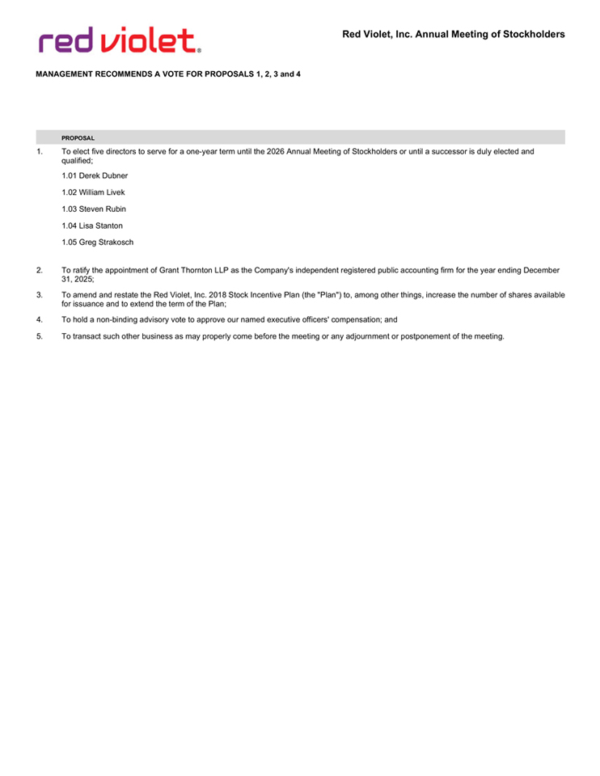
Red Violet, Inc. Annual Meeting of Stockholders MANAGEMENT RECOMMENDS A VOTE FOR PROPOSALS 1, 2, 3 and 4 PROPOSAL 1. To elect five directors to serve for a one-year term until the 2026 Annual Meeting of Stockholders or until a successor is duly elected and qualified; 1.01 Derek Dubner 1.02 William Livek 1.03 Steven Rubin 1.04 Lisa Stanton 1.05 Greg Strakosch 2. To ratify the appointment of Grant Thornton LLP as the Company's independent registered public accounting firm for the year ending December 31, 2025; 3. To amend and restate the Red Violet, Inc. 2018 Stock Incentive Plan (the "Plan") to, among other things, increase the number of shares available for issuance and to extend the term of the Plan; 4. To hold a non-binding advisory vote to approve our named executive officers' compensation; and 5. To transact such other business as may properly come before the meeting or any adjournment or postponement of the meeting.

